Week 1; Recycling and Green Tips MAVO/HAVO/VWO
This theme we are discussing energy, one way of preserving and creating energy is by recycling and thinking about how we use our electronics and the environment. This lesson you are going to learn more about what you can do to be more green and recycle. You will read some articles and find the difference between some British English and American English words.
A. Before we start answer the following question in pairs: We recycle because we love the world we live in, what do you think is amazing about our earth?
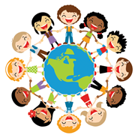

Text 1: Plastic Bottles MAVO/HAVO/VWO
Before we find out more about ways we can live greener we should have a look at some of the problems caused by the way we live now. A large problem of the last years is plastics. As you may know we now have a law in place that forces us to pay of plastic shopping bag in all shops. One other major plastic waste issue is water bottles.
Read the following article and answer the questions below.
https://kids.nationalgeographic.com/explore/nature/kids-vs-plastic/pollution/
B. Write down any words you don’t know and look up the Dutch translations that fit in the context:
English Word | Dutch Translation
1
2
3
4
5
6
7
8
9
10

C. Answer the following questions in English. MAVO/HAVO/VWO
- What does the turtle think the ‘white blob’ is?
- What is the ‘white blob’ actually?
- Plastic isn’t necessarily bad. What is the problem with plastic? Write this down in your own words.
- How much plastic ends up in the ocean every year?
- How does the plastic end up in the ocean?
- Plastic trash is different than other forms of trash. What makes it different?
- What can you do personally to reduce plastic waste?
D. Answer the following questions in English MAVO/HAVO/VWO
- How many bottles of water, or other drinks do you drink per week? What do you do with the bottle once you finished your drink? Explain why.
- Why is it important to know that plastic bottles are made of crude oil/fossil fuels? Explain your answer.
- Which of the tips in the text would you use for yourself or to tell others about in future? Explain your answer.
E. Answer the following questions in English HAVO/VWO
1. What can you say about the tone the writer uses in the article? (Positive, negative, disinterested, angry, etc). Explain your answer.
2. What is the aim of the article, in other words what does the writer hope the effect is on the reader? Explain your answer.
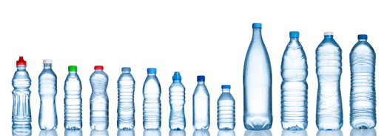

Text 2: Green Tips MAVO/HAVO/VWO
You are going to read an article on the National Geographic Kids website about how we can change some little things in our lives to make them a bit greener.
https://kids.nationalgeographic.com/explore/science/green-tips/
F. Write down any words you don’t know and look up the Dutch translations that fit in the context:
English Word | Dutch Translation
1
2
3
4
5
6
7
8
9
10

G. In your own words explain what the tips are, give the title and a short explanation for all 7 of them.
1.
2.
3.
4.
5.
6.
7.
H. Order of effectiveness – now you understand what each of the tips are, make a list with on number 1 the one you think is most effective and on number 7 the least effective. Explain why you arranged them this way. I have put them in this order because, ...

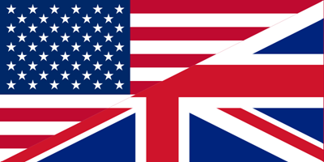
American vs. British English HAVO/VWO
As the texts are written by an American TV production company – National Geographic – a lot of the words used in the text are typical for the American people. Most of you will understand what these words mean, but which words would we use in British English.
I. Look up the British English synonyms for the following words.
American | British English
Landfill
Waste
Neighborhood
Trash
Fall (season)
Pest
Faucet
Soccer

Text 3: Happy People, Happy Planet MAVO/HAVO/VWO
National Geographic has looked for some help to show how important taking care of the planet is. This year they found support in Pharrell Williams who supported them during the United Nation’s International Day of Happiness.
J. Read the interview with him below and answer the questions.
https://kids.nationalgeographic.com/explore/100-things-to-make-you-happy/
- In your own words explain what Pharrell says about the theme ‘happy people, happy planet’.
- Name at least 3 things kids can do to make the earth happy.
- What does Pharrell mean with ‘happiness is contagious’?
- What is meant with ‘flip the switch’, how does this help the environment?

Top Tips HAVO/VWO
K. Explain in your own words how the following tips Pharrell mentioned would help the environment.
Ride a bike:
Learn as much as you can about climate change:
Recycle plastics:
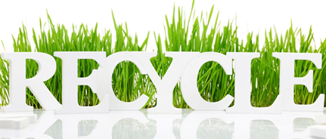

Done with all of your work? Have a look at these recycling and green games:
http://kids.nationalgeographic.com/explore/plan-it-green/
http://kids.nationalgeographic.com/games/action/recycle-roundup/
http://kids.nationalgeographic.com/kids/games/iggygames/kung-fu-trash-master/

